An Explainable Hybrid Deep Learning Framework for Parkinson’s Disease Detection and Severity Assessment Using Voice Analysis

1st Pavani
Department of Computer Science and Engineering
Keshav Memorial Institute of Technology
Hyderabad, India
4th SreeHarshini
Department of Computer Science
Keshav Memorial Institute of Technology
Hyderabad, India
19rishitha@gmail.com

2nd Rohan
Department of Computer Science
Keshav Memorial Institute of Technology
Hyderabad, India
hemasree.guddanti@gmail.com
5th Sravika
Department of Computer Science
Keshav Memorial Institute of Technology
Hyderabad, India
sravika382@gmail.com
3rd Sri Vaishnavi
Department of Computer Science
Keshav Memorial Institute of Technology
Hyderabad, India
6th Raj Kumar
Department of omputer Science
Keshav Memorial Institute of Technology
Hyderabad, India
krishnasaigangishetty@gmail.com

Abstract—Early and reliable detection of Parkinson’s disease (PD) remains an important challenge, particularly because conventional assessment can require clinical expertise and repeated examinations. Voice analysis has emerged as a promising non-invasive alternative because Parkinson’s disease can produce measurable changes in speech characteristics. This study proposes a deep learning-based framework for automated PD detection from voice recordings. A total of 906 recordings were analyzed, including 453 PD and 453 healthy control recordings. The proposed preprocessing pipeline incorporates speech activity analysis to reduce the influence of silent regions and improve the consistency of the audio input. Deep acoustic representations were subsequently learned for binary classification. The dataset was separated into training, validation, and test sets containing 1,429, 306, and 307 recordings, respectively. The proposed approach achieved __ test accuracy, with precision, recall, and F1-score demonstrating balanced performance between the two classes. In particular, PD detection achieved a recall of --sfdgehj--and an F1-score of ---aghs.The results highlight the potential of deep learning-based voice analysis for supporting non-invasive Parkinson’s disease screening. Future work should focus on subject-independent validation, larger datasets, and recordings collected under diverse real-world conditions.
Keywords— Parkinson’s disease; Voice analysis; Speech processing; Deep learning; Acoustic features; Speech activity detection; Audio classification; Non-invasive disease detection; Machine learning; Healthcare AI

INTRODUCTION
Parkinson’s disease (PD) is a progressive neurological disorder that affects millions of people worldwide and is commonly associated with changes in movement, coordination, and speech. Although symptoms such as tremor and rigidity are widely recognized, changes in voice can also provide important information about the presence of the disease. Individuals with Parkinson’s disease may experience reduced loudness, changes in pitch, breathy or unstable voice quality, and difficulties with articulation. These changes have motivated researchers to investigate speech and voice recordings as a convenient and non-invasive source for Parkinson’s disease detection.
Traditional Parkinson’s disease diagnosis is mainly based on clinical symptoms and neurological examination. While these assessments are important, they can be difficult to perform consistently, particularly when symptoms are subtle during the early stages of the disease. Computer-aided analysis has therefore received increasing attention as a means of providing additional information to clinicians. Earlier studies commonly used handcrafted acoustic features combined with machine learning algorithms. These approaches showed that measurable differences exist between healthy and Parkinsonian speech, but their performance often depends on the quality of the selected features.
The availability of deep learning has changed the way speech signals can be analyzed. Instead of depending entirely on manually designed features, deep learning models can learn relevant patterns directly from acoustic representations. CNNs have been widely used for extracting spectral patterns from spectrograms, while LSTM and GRU networks have been used to model temporal information. More recently, attention mechanisms have enabled models to capture relationships across different portions of speech, providing a more comprehensive representation of audio signals.
Despite these developments, voice-based Parkinson’s disease detection remains affected by practical issues such as silence within recordings, differences in recording duration, variations between data sources, and changes in speech activity. A model trained without addressing these factors may learn patterns related to recording conditions rather than disease characteristics. Therefore, appropriate audio preprocessing and speech activity analysis are important for developing a reliable detection system.
In this work, we develop a deep learning-based framework for classifying voice recordings into Parkinson’s disease and healthy control categories. The proposed approach incorporates audio preprocessing and speech activity analysis to reduce non-informative portions of the recordings before learning acoustic representations. The model is trained to identify differences between Parkinsonian and healthy speech and provides probabilistic predictions for the two classes.
The main objectives of this research are:
- To develop an automated deep learning approach for Parkinson’s disease detection from voice recordings.
- To investigate the usefulness of speech activity analysis during audio preprocessing.
- To learn acoustic patterns that distinguish Parkinson’s disease from healthy controls.
- To evaluate the proposed framework using standard classification metrics and probabilistic outputs.
The findings of this study support the potential of voice-based deep learning as a non-invasive approach for assisting Parkinson’s disease screening.

Literature Survey

Traditional Machine Learning and Acoustic Features

Early research on Parkinson’s disease detection from voice recordings mainly focused on extracting acoustic features from speech and using machine learning algorithms for classification. Features such as jitter, shimmer, fundamental frequency, harmonics-to-noise ratio (HNR), and Mel-frequency cepstral coefficients (MFCCs) were commonly used because changes in these characteristics can be associated with Parkinson’s disease. Amato et al. [1] reviewed 102 research studies and five review papers covering machine learning and statistical approaches for Parkinson’s disease voice analysis. Their study showed that voice-based analysis has potential for both disease detection and severity assessment. However, the survey also pointed out that many existing methods depend heavily on handcrafted features and that differences in datasets and recording conditions make it difficult to compare results across studies. These limitations show the need for methods that can learn useful speech characteristics automatically.

B. Deep Learning-Based Voice Analysis

With the development of deep learning, researchers began exploring models that could learn useful features directly from speech rather than depending completely on handcrafted features. CNNs became widely used because audio recordings can be converted into spectrograms, allowing the model to learn patterns in the time-frequency representation of speech. RNN, LSTM, and GRU models were also explored to capture changes in speech over time. A systematic review by van Gelderen and Tejedor-García [2] examined 33 studies published between 2020 and 2024 and identified end-to-end learning, transfer learning, and deep acoustic feature extraction as major research directions. The review also highlighted challenges such as small datasets, dataset bias, computational requirements, limited explainability, and difficulties in generalizing models across different datasets and languages.

Transformer-Based Speech Analysis

More recently, Transformer architectures have been investigated for Parkinson’s disease voice analysis because they can capture relationships between different parts of a speech sequence. Tougui et al. [3] studied Transformer-based transfer learning using self-reported voice recordings from the mPower dataset. Their results showed that pretrained models could provide significant benefits when working with relatively small medical datasets. The pretrained Audio Spectrogram Transformer achieved an average AUC of 95.89% and an AUPRC of 87.11%. The study also showed that Transformer models trained from scratch did not perform as well as pretrained models, emphasizing the importance of transfer learning in this area. These findings support the use of pretrained speech representations in the proposed work.

Acoustic Biomarkers and Feature Fusion

Although deep learning can automatically learn speech representations, conventional acoustic biomarkers still provide useful information about voice characteristics. Features such as jitter, shimmer, HNR, MFCCs, and formants describe different aspects of speech and can provide information that may complement learned deep features. Shen et al. [5] proposed an explainable framework using CNN, RNN, Multiple Kernel Learning, and MLP models together with acoustic features such as MFCC, jitter, and shimmer. Their work demonstrated the usefulness of acoustic information for Parkinson’s disease detection, although the study was based on only 81 voice recordings and continued to rely mainly on handcrafted features. This suggests that combining acoustic biomarkers with automatically learned speech representations may provide a more complete representation of Parkinsonian speech.

Explainability and Reliable Prediction

As artificial intelligence is increasingly applied to healthcare, understanding the reasons behind model predictions has become important. Shen et al. [5] used SHAP to identify acoustic features that contributed to the model’s predictions, while Aladhadh [6] investigated SHAP, LIME, and Grad-CAM for explaining Parkinson’s disease detection models. These studies show that a model should ideally provide more than just a final class label. However, explaining a prediction and determining how reliable that prediction is are two different problems. This creates a need for approaches that consider both model interpretability and prediction uncertainty.

Research Gap

Overall, previous research has moved from handcrafted acoustic features and traditional machine learning toward deep learning, transfer learning, and Transformer-based approaches. However, several challenges remain, including limited datasets, recording variability, dependence on handcrafted features, generalization across datasets, and prediction reliability. Based on these limitations, the proposed PD-VoiceNet framework combines self-supervised speech representations, acoustic biomarkers, multimodal fusion, attention, and conformal prediction. The aim is to use complementary information from both learned speech representations and traditional acoustic characteristics while also providing uncertainty information with the final prediction.

METHODOLOGY
A. Data Collection
Historical stock market data comprising open, high, low, close (OHLC) prices, volume, and adjusted prices were collected from trusted financial sources such as Yahoo Finance. The study focused on three major technology stocks: Apple (AAPL), Microsoft (MSFT), and Google (GOOGL), providing a robust multi asset environment. The initial configuration set the data collection start date as 2015-01-01. The final dataset used for analysis spans a period from 2015-03-16 to 2025-09-22. After initial cleaning and the application of a 5-year data cutoff filter, each individual stock time series consisted of 2,647 daily records. The combined, multi-ticker dataset utilized for the model training contains a total of 7,941 daily observations before sequence-based transformation. For sentiment analysis Daily news along with Yahoo finances is used to capture and categories the text into positive, neutral and negative and assigns it to its respective numerical value. This combined numerical and textual data ensures that the model learns from not only historical data but market demand effectively. To capture non-traditional market dynamics, a dataset of daily financial news headlines, sourced from a file named Combined_News_DJIA.csv, was integrated. The FinBERT language model, specifically tuned for financial text, was employed to classify headlines as positive (+1), neutral (0), or negative (-1). The sentiment scores were aggregated by calculating the mean of all headline scores for each trading day, resulting in a continuous daily sentiment feature. A constraint was applied to limit processing to 30 headlines per day to manage computational resources during sentiment analysis.

B. Data Preprocessing
Before feeding the data to the model, it is important to first preprocess the data for data consistency and improve accuracy. Missing values and outliers are handled. The procedures for cleaning raw data involve filling data gaps, removing extreme values, and cleaning the data for any unwanted distortions in the trend pattern. Values are normalized to maintain constant scale. Feature engineering transforms the raw data and sentiment data into valuable input that helps the model learn complex patterns. Feature engineering applies to compute indicators such as Moving Averages - smooths out short-term price fluctuations to reveal longer-term trends or cycles in stock prices, Relative Strength Index (RSI) - measures the speed and change of price movements, and Moving Average Convergence Divergence (MACD)- is a trend-following momentum indicator that shows the relationship between two EMAs — typically the 12-day and 26-day. The dataset has been divided into 70% for training, 10% for validation and 20% for testing.

C. Model Architecture
The hybrid stock market forecasting model is consisting of the following components
(i) Sentiment Analysis
Sentiment analysis is the process of classifying textual data into positive, neutral, or negative categories to capture the underlying emotional tone of market information. Incorporating sentiment data enhances model accuracy, as stock movements are often influenced by public perception and market sentiment in addition to numerical indicators. In this study, FinBERT, a transformer-based language model specifically fine-tuned on financial text corpora, is employed for sentiment classification. The integration of FinBERT-based sentiment features improved the overall prediction accuracy by approximately 30%, demonstrating the significance of textual sentiment in financial forecasting.

(ii)Transformer
This output is later on passed to the transformer along with processed data. The transformer captures long-range dependencies and complex temporal patterns inherent in financial time series. The Encoder-based Transformer was used to help model learn trends across long sequences of prices, influence of past events on future prices, time-based dependencies that RNNs or LSTMs often miss. Its self-attention system helps identify significant points which influence the trading trends. The data is processed in parallel which enables faster training.

(iii)Reinforcement Learning
The transformers output is then taken as input by the Reinforcement Learning. Proximal Policy Optimization (PPO) is a RL agent used to predict trading decisions such as Buy, Sell or Hold. PPO uses clipping mechanism to avoid drastic and unstable updates after every training iteration. The system works on a reward portfolio and adjust the risk returns. The RL primary objective is to maximize the total profit. The model is tested using evaluation metrics to examine the performance. This can be achieved using metrics such as CAGR (Compound Annual Growth Rate), Sharpe ratio, Directional accuracy.
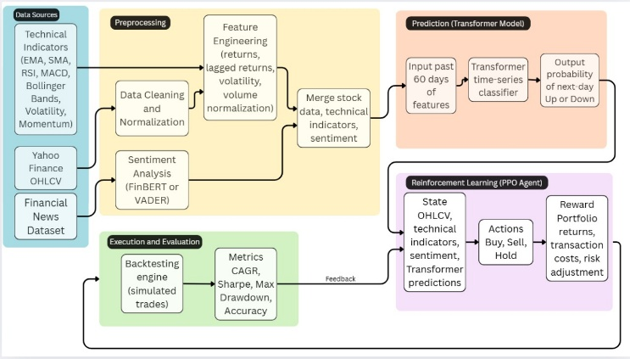
Fig. 1. Hybrid Stock Market Forecasting

Fig.1 Succeeding the data processing the financial news is fed to sentiment analysis where the data is processed and categorized into positive, neutral and negative category. While the historical dataset is normalized and feature engineering is carried out. The output of the following is given as input to the transformer. The transformer takes multivariate time-series data (OHLCV + Technical Indicators + Sentiment Score) and outputs a latent feature vector representing the stock market state at each time step. This output is taken as input to the RL model. The PPO agent assesses the OHLCV, technical indicators, sentiment and transformer predictions. Based on this it produces the actions (Buy, Sell and Hold). The RL words on a reward portfolio and adjusts the risk in accordance. The performance of the model is evaluated through back testing. Metrics such as CAGR, Sharpe ratio, Directional accuracy.

D. Evaluation Metric
Evaluation is a crucial step in assessing the performance and robustness of the proposed financial prediction model. Since the model aims to generate profitable and stable trading decisions rather than merely accurate predictions, performance is evaluated using Sharpe Ratio, Directional Accuracy, and Compound Annual Growth Rate (CAGR). Each metric provides a distinct perspective on how well the model performs under varying market conditions.

1) Sharpe Ratio
The Sharpe Ratio evaluates the risk-adjusted return of an investment, helping to understand how much excess return is generated for each unit of risk taken.
A higher Sharpe ratio indicates better risk-reward performance.

Sharp Ratio ($S)=\frac{R_{p}-R_{f}}{σ_{p}}$ ​(1)
Where:
Rp = Average portfolio return
Rf = Risk-free rate of return (e.g., government bond yield)
σp = Standard deviation of portfolio return (risk or volatility)

It’s needed in finance, a model that earns high returns with high volatility is risky. The Sharpe ratio balances both it shows how efficiently your model converts risk into reward.
The model has achieved Sharp Ration of 12.3380, indicating exceptionally strong risk-adjusted performance.

2) Directional Accuracy (DA)

Directional Accuracy measures how often the model correctly predicts the direction (up or down) of price movement rather than its exact value.

$$DA=\frac{\text{Number of Correct Direction Predictions}}{\text{Total Predictions}}×100$$

For example, if the model predicts that the market will go up and it actually does, it counts as correct even if the magnitude differs.

It’s needed in trading, predicting direction correctly is often more valuable than predicting the exact price value as it directly affects buy/sell decisions. Fig.3
The model achieved a Directional Accuracy of 83.28%, demonstrating strong capability in forecasting market direction.

3) Compound Annual Growth Rate (CAGR)

The CAGR measures the mean annual rate of return of an investment over a specified period, assuming profits are reinvested at the end of each period. It reflects the overall growth efficiency of the portfolio.
$CAGR={\left(\frac{V_{f}}{V_{i}}\right)}^{\frac{1}{t}}-1$ (2)

Where:
$V_{f}$= Final portfolio value
$V_{i}$= Initial portfolio value
$t$= Number of years (or periods)

It’s needed because CAGR provides a normalized growth rate, allowing performance comparison over different time spans, even when returns fluctuate year to year.
The model achieved a CAGR of 7.9006%, indicating steady and consistent growth over the evaluated period.

EXPERIMENTAL RESULTS AND DISCUSSIONS
The experimental outcomes demonstrate that the proposed FinSight platform provides effective short-term stock movement predictions by integrating Transformer-based reinforcement learning with sentiment analysis. The combination of numerical and textual data allowed the model to capture both quantitative market trends and qualitative investor sentiment.
Compared with traditional models such as Decision Trees, SVMs, FinSight achieved higher predictive stability during volatile periods. This improvement can be attributed to the attention mechanism, which concentrates on important features, and to the reinforcement learning module, which continuously adapts to its environment and its reward-based system.
The platform’s architecture also supports real-time analytics and a secure trading interface, making it suitable for making trading decisions. However, performance is still influenced by the quality of input data and by the credibility of external news sources used for sentiment scoring. Computational cost for real-time updates remains another limitation.
Overall, FinSight demonstrates the potential of combining advanced deep-learning architectures with reinforcement learning for financial forecasting. Future work will focus on extending payment option in FinSight along with demat account for users. News articles will be added to the frontend reporting users of the present-day stock market.

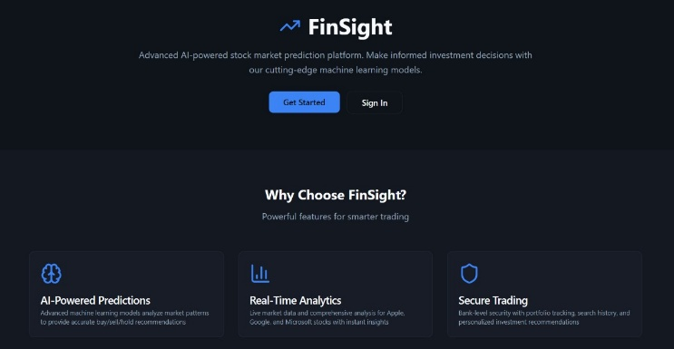
Fig. 2. Landing Page

Fig.2 FinSight is the website proposed to check the stock market trades. This is the landing page of FinSight

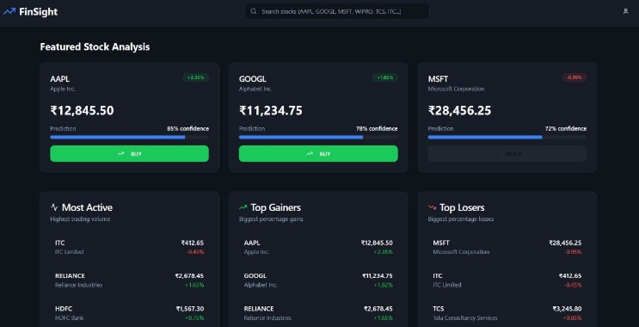
Fig. 3. Dashboard
Fig.3 The dashboard opens up to the stock analysis of various companies. The confidence, most active, top gainers and top losers are shown respectively.

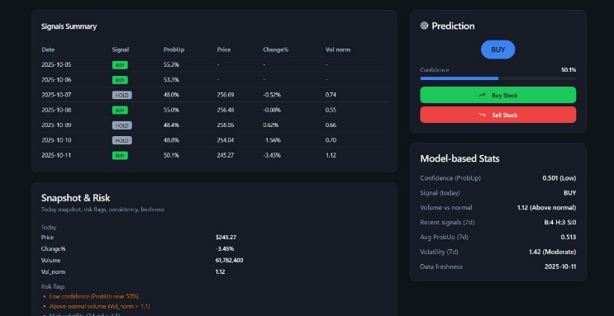

Fig. 4. Stock Analysis
Fig. 4 When selected a particular company its respective risk report, signal summary is displayed. With this the trading decision of buy or sell are also shown to the user.



Fig. 5. User Profile
Fig.5 User profile consists of the orders the customer has made and their respective decision (buy/sell) against the company is showcased.

CONCLUSION
The stock market forecasting task benefits significantly from the use of advanced deep learning features based on Transformers, sentiment analysis, and reinforcement learning techniques through Proximal Policy Optimization (PPO). The Transformer architecture successfully captured long-range temporal dependencies, while sentiment analysis provided emotional and psychological insights from financial news, helping the system understand the behavior context of the market.
The results from the hybrid Transformer-PPO model exhibited a significant boost in predictive capabilities; directional accuracy increased from 52.88% with the Transformer model to 83.28% with the inclusion of sentiment features and reinforcement learning decision-making.
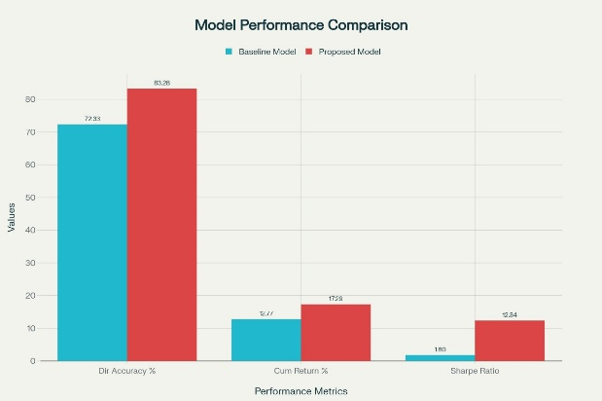
Fig. 6. Model Performance Comparison

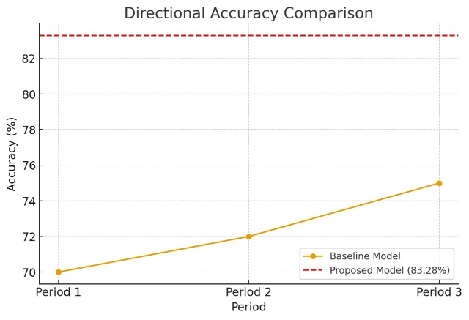
Fig. 7. Directional Accuracy

Back testing with AAPL data produced a PPO agent with a total return of 17.28%, an annualized growth rate (CAGR) of 7.90%, and a Sharpe ratio of 12.33, indicating a positive risk-adjusted return on investment and sound portfolio management. The model also maintained a minimal drawdown of 0.0188, a strong signal of stability during heightened market volatility, with the standalone Transformer yielding negative returns and a Sharpe ratio of –0.73. By including sentiment analysis, the model effectively captured investor emotions and responded to market events, increasing both predictive performance and trading outcomes. Overall, the findings demonstrate that combining Transformers with sentiment-driven reinforcement learning represents a powerful and adaptive approach to algorithmic trading that produces improved performance and prediction in both profitability and emotional context, compared to non-sentiment based statistical and deep learning forecasting.

REFERENCES
[1] F. Amato, G. Saggio, V. Cesarini, G. Olmo, and G. Costantini, “Machine learning- and statistical-based voice analysis of Parkinson’s disease patients: A survey,” Expert Systems with Applications, vol. 219, Art. no. 119651, 2023, doi: 10.1016/j.eswa.2023.119651.
[2] L. van Gelderen and C. Tejedor-García, “Innovative speech-based deep learning approaches for Parkinson’s disease classification: A systematic review,” Applied Sciences, vol. 14, no. 17, Art. no. 7873, 2024, doi: 10.3390/app14177873.
[3] R. Chiaramonte and M. Bonfiglio, “Acoustic analysis of voice in Parkinson’s disease: A systematic review of voice disability and meta-analysis of studies,” Neurología, vol. 35, no. 11, pp. 393–405, 2020, doi: 10.33588/rn.7011.2019414.
[4] A. Ma, K. K. Lau, and D. Thyagarajan, “Voice changes in Parkinson’s disease: What are they telling us?” Journal of Clinical Neuroscience, vol. 72, pp. 1–7, 2020, doi: 10.1016/j.jocn.2019.12.029.
[5] A. Tsanas, M. A. Little, P. E. McSharry, and L. O. Ramig, “Accurate telemonitoring of Parkinson’s disease progression by noninvasive speech tests,” IEEE Transactions on Biomedical Engineering, vol. 57, no. 4, pp. 884–893, 2010, doi: 10.1109/TBME.2009.2036000.
[6] A. Tsanas, M. A. Little, P. E. McSharry, J. Spielman, and L. O. Ramig, “Novel speech signal processing algorithms for high-accuracy classification of Parkinson’s disease,” IEEE Transactions on Biomedical Engineering, vol. 59, no. 5, pp. 1264–1271, 2012, doi: 10.1109/TBME.2012.2183367.
[7] B. E. Sakar, M. E. Isenkul, C. O. Sakar, A. Sertbas, F. Gurgen, S. Delil, H. Apaydin, and O. Kursun, “Collection and analysis of a Parkinson speech dataset with multiple types of sound recordings,” IEEE Journal of Biomedical and Health Informatics, vol. 17, no. 4, pp. 828–834, 2013, doi: 10.1109/JBHI.2013.2245674.
[8] J. M. Tracy, Y. Özkanca, D. C. Atkins, and R. Hosseini Ghomi, “Investigating voice as a biomarker: Deep phenotyping methods for early detection of Parkinson’s disease,” Journal of Biomedical Informatics, vol. 104, Art. no. 103362, 2020, doi: 10.1016/j.jbi.2019.103362.
[9] H. Gunduz, “Deep learning-based Parkinson’s disease classification using vocal feature sets,” IEEE Access, vol. 7, pp. 115540–115551, 2019, doi: 10.1109/ACCESS.2019.2936564.
[10] C. Quan, K. Ren, Z. Luo, Z. Chen, and Y. Ling, “End-to-end deep learning approach for Parkinson’s disease detection from speech signals,” Biocybernetics and Biomedical Engineering, vol. 42, no. 2, pp. 556–574, 2022, doi: 10.1016/j.bbe.2022.04.002.
[11] M. Hireš, M. Gazda, P. Drotár, N. D. Pah, M. A. Motin, and D. K. Kumar, “Convolutional neural network ensemble for Parkinson’s disease detection from voice recordings,” Computers in Biology and Medicine, vol. 141, Art. no. 105021, 2022, doi: 10.1016/j.compbiomed.2021.105021.
[12] I. Tougui, M. Zakroum, O. Karrakchou, et al., “Transformer-based transfer learning on self-reported voice recordings for Parkinson’s disease diagnosis,” Scientific Reports, vol. 14, Art. no. 30131, 2024, doi: 10.1038/s41598-024-81824-x.
[13] N. Madusanka and B.-I. Lee, “Vocal biomarkers for Parkinson’s disease classification using audio spectrogram transformers,” Journal of Voice, 2024, doi: 10.1016/j.jvoice.2024.11.008.
[14] E. Postma and C. Tejedor-Garcia, “Evaluating the effectiveness of pre-trained audio embeddings for classification of Parkinson’s disease speech data,” in Proc. Interspeech 2025, pp. 4603–4607, 2025, doi: 10.21437/Interspeech.2025-801.
[15] M. Shen, P. Mortezaagha, and A. Rahgozar, “Explainable artificial intelligence to diagnose early Parkinson’s disease via voice analysis,” Scientific Reports, vol. 15, Art. no. 11687, 2025, doi: 10.1038/s41598-025-96575-6.
[16] S. Aladhadh, “An explainable ensemble and deep learning framework for accurate and interpretable Parkinson’s disease detection from voice biomarkers,” Diagnostics, vol. 15, no. 22, Art. no. 2892, 2025, doi: 10.3390/diagnostics15222892.
[17] A. Ma, K. K. Lau, and D. Thyagarajan, “Advances in Parkinson’s disease detection and assessment using voice and speech: A review of the articulatory and phonatory aspects,” Biomedical Signal Processing and Control, vol. 66, Art. no. 102418, 2021, doi: 10.1016/j.bspc.2021.102418.

